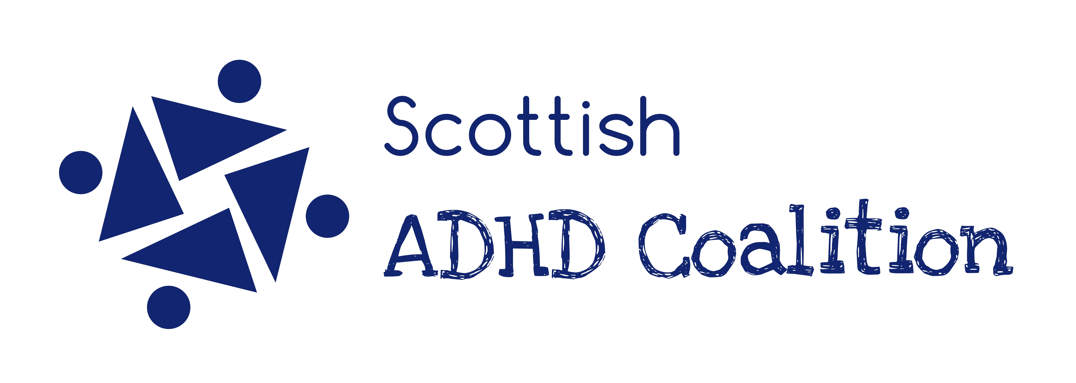

Briefing for MSPs on ADHD in Scotland

June 2018

# What is ADHD?

ADHD is a neurodevelopmental condition affecting brain structure and neurotransmission: the way in which messages are communicated around the brain and different areas of the brain are activated. ADHD is caused by a complex mix of environmental and genetic factors, but is a strongly hereditary condition. ADHD is usually a lifelong condition and becomes apparent in childhood (before the age of 12).

ADHD has three core symptoms which affect people with it to different degrees.

|  |  |
| --- | --- |
| Inattention | Difficulties with concentration, short term and working memory  Difficulties with planning and getting started (activation)  Difficulty with organisation and losing things  Easily distracted by small things which others wouldn't notice |
| Impulsiveness | Acting or speaking on the spur of the moment without thinking through the consequences.  Difficulty controlling emotions |
| Hyperactivity | Whilst adults with ADHD are usually much less active than children with ADHD, they may still have symptoms such as restlessness and the need to tap or fidget. Some people are diagnosed with attention deficit disorder (ADD) without hyperactivity: this is particularly often the case for girls and women. |

Whilst they are not core symptoms, many people with ADHD have problems with sleep and with regulating their emotions.

ADHD can be diagnosed on its own, but often comes alongside other associated conditions. These include sensory difficulties (being over- or under- sensitive to sights, sounds and other sensations), dyslexia, dyspraxia (coordination difficulties), tics, and autistic spectrum disorder.

**How do diagnosis rates in Scotland compare to prevalence?**

The consensus of NICE and the Scottish Intercollegiate Guidelines Network (SIGN) is that approximately 5% of children have ADHD, and approximately 1.5% have severe ADHD (hyperkinetic disorder). However, treatment rates in Scotland are generally much lower than this, and there is considerable variation between health boards.



It is thought that around 2.5 – 4% of the adult population would benefit from treatment for ADHD[1], but ISD Scotland data shows that less than 1 in 1000 adults (0.1%) in Scotland were taking medication for ADHD in 2017. Because ADHD was not as well understood in the past as it is now, there are many adults with ADHD who never received a diagnosis when they were children.

For a full analysis of treatment rates across Scotland, see <https://www.scottishadhdcoalition.org/adhd-in-scotland/>

For those with undiagnosed ADHD, the condition can seriously affect their ability to achieve what they want to, achieve and avoid exclusion at school, hold down a job, manage relationships and negotiate family life. If not addressed, ADHD can also lead on to mental health problems like anxiety and depression.

**What is the state of services in Scotland for people with ADHD?**

We carried out a survey about services for children in Scotland which was published earlier this year. The report ‘Attending to Parents’ can be read at <https://www.scottishadhdcoalition.org/>

The main findings were that:

* SIGN and NICE recommend multimodal treatment for ADHD, including medication, parent training, school interventions and psychological support. However, in many areas, medication is all that is offered. Parents who refuse medication for their children are often discharged from services.
* CAMHS waiting times are excessively long.
* Teachers need much greater training on ADHD.

Adult services in Scotland are recognised by the Royal College of Psychiatrists of Scotland as under-developed. They published guidelines in 2017 about how psychiatrists should diagnose and manage ADHD. These guidelines recognise that there are not many consultant psychiatrists in Scotland with a specialist interest in ADHD running dedicated ADHD clinics, and therefore these guidelines help all psychiatrists to assess and treat ADHD consistently. However many adults struggle to access diagnosis and treatment. The Scottish ADHD Coalition will be doing further work on this later in the year.

**Positive developments in Scotland which could be highlighted**

* The Scottish ADHD Coalition was launched in summer 2017 to bring together the voluntary organisations providing support to families and adults affected by ADHD across Scotland.
* The Coalition published [a guide to ADHD for Employers](https://www.scottishadhdcoalition.org/adhd-and-employment/) this year, and is engaged in training Disability Employment Advisors within Job Centres about ADHD.
* The Coalition is also working with Education Scotland to produce resources for teachers about ADHD, although more investment is needed in teacher training.
* The Dundee and Angus ADHD group will be launching a research report on the needs of people with ADHD across their area on 22nd June.
* Professor Helen Minnis will be leading a Glasgow University trial starting this August called SPARCLAR (Support for Parents of Children Living with ADHD). It will be a randomised trial comparing the ADHD-specific Parents Inc training to the Incredible Years programme.

# Further reading and references

* Royal College of Psychiatrists of Scotland [***Guidelines on Adult ADHD***](https://www.rcpsych.ac.uk/pdf/ADHD_in_AdultsFINAL_GUIDELINES_JUNE2017.pdf) for health professionals, 2017
* Professor Thomas Brown – [half hour video introduction to ADHD](https://www.understood.org/en/learning-attention-issues/child-learning-disabilities/add-adhd/adhd-explained-a-28-minute-primer)
* [Management of Attention Deficit and Hyperkinetic Disorders in Children and Young People](http://www.sign.ac.uk/sign-112-management-of-attention-deficit-and-hyperkinetic-disorders-in-children-and-young-people.html) (Clinical Guideline 112). Scottish Intercollegiate Guidelines Network (SIGN), 2009.
* [Attention deficit hyperactivity disorder: diagnosis and management](https://www.nice.org.uk/guidance/ng87) (Clinical Guideline NG87). National Institute for Health and Care Excellence (NICE), 2018.

***For more information, contact Geraldine Mynors at chair@scottishadhdcoalition.org***

***Visit*** [***www.scottishadhdcoalition.org***](http://www.scottishadhdcoalition.org) ***to find out more about us and ADHD in Scotland.***

***Scottish ADHD Coalition, Scottish Charitable Incorporated Organisation no. SC047630***

1. 1. Faraone SV, Biederman J. What is the prevalence of adult ADHD? Results of a population screen of 966 adults. Journal of attention disorders. 2005;9(2):384-91.

  